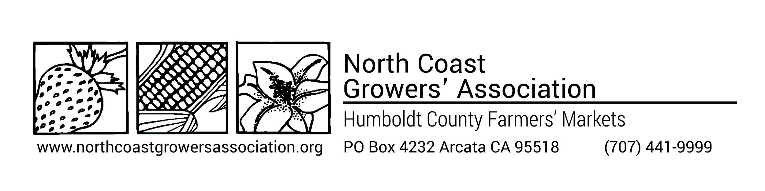
2024 Second Producer Form
If you plan to sell on behalf of another producer this year, or to have another producer sell for you, please complete this form and submit it along with your application and membership dues.

Farm Name: ____________________________________________________________________________________________

Member Name: _________________________________________________________________________________________

I will be selling for the following producers this 2022 season:
Producer #1
Member Name:___________________________________________________
Farm Name:______________________________________________________
I will be selling the following products for the above producer: ____________________________________________
_________________________________________________________________________________________________________

Producer #2
Member Name:___________________________________________________
Farm Name:______________________________________________________
I will be selling the following products for the above producer: ___________________________________________
_________________________________________________________________________________________________________

I give the following producers permission to sell on my behalf:
Producer #1
Member Name:______________________________________ Farm Name: ______________________________________
Producer #2
Member Name:______________________________________ Farm Name :______________________________________

I have read and understand the Second Producer Rules and Regulations (see next page) and agree to abide by them.

Member’s Signature _____________________________________________________________ Date _________________

NCGA Rules and Regulations regarding Second Producers
- You may only sell products that you have grown. You cannot sell on a commission basis for anyone else. As a Certified Producer (CP), you may sell produce for up to two other Certified Producers, in addition to your own. According to the CA Department of Food and Agriculture Direct Marketing regulations, you may sell for only two additional producers in a twelve month period and are required to have the names of the other producers who you are selling for, or who are selling for you, listed on your Producers Certificate.
- It is required that you inform the market manager when you are going to be selling for a Second Producer.
- You can have an authorized representative sell for you, but they cannot receive a commission on sales.

CDFA Regulation Highlights regarding Second Producers (Updates effective 1/1/21)
A certified producer can have an “authorized representative” sell and/or conduct business on their behalf at a CFM but must provide the county agricultural commissioner with a list of those authorized representatives.
If a certified producer is cross-referenced, and authorized to sell on another certified producers’ behalf, and the market allows this practice, the certified producer must:
- Conspicuously post each valid CPC and the respective sign or banner
- Separate and identify each certified producer’s agricultural products
- When selling products as organic for the second producer, conspicuously post the state organic registration and organic certification (if applicable)
- Not sell the same commodity, variety or product on the same day, at the same CFM
- Offer more of your own products by volume (weight or dollar value) than those of the second producer
- Have a documented, signed agreement in place before sales commence
- Only sell certifiable products of the second producer (e.g. no processed products)
- Provide a product list (load list) to the market manager within 48 hours of the conclusion of the market day
- Maintain records for at least 3 years when selling for another producer. Records include the amount of product transferred between producers and the amount sold.
- Obtain and submit to the agricultural commissioner written authority from the second producer to sell on their behalf.

The full text of the state Second Producer regulations can be found at the link below.

§ 1392.4. Conditions of Direct Marketing
https://govt.westlaw.com/calregs/Document/I3D530F82E71F482CB74C9213BB98621C?viewType=FullText&originationContext=documenttoc&transitionType=CategoryPageItem&contextData=(sc.Default)

§ 1392.4. Conditions of Direct Marketing
https://govt.westlaw.com/calregs/Document/I3D530F82E71F482CB74C9213BB98621C?viewType=FullText&originationContext=documenttoc&transitionType=CategoryPageItem&contextData=(sc.Default)

Second Producer Regulations

(e) A certified farmers' market may allow, or prohibit, a certified producer to sell at that market certified agricultural products on behalf of a maximum of two other certified producers, including, but not limited to, separate entities, such as partnerships, in which the certified producer has an interest as an individual member. If such a practice is allowed, the following provisions shall be met by the certified producer:
(1) A certified producer shall not represent, nor be represented by more than two other certified producers in a 12-month period.
(2) Each certified producer's certified agricultural products to be sold or offered for sale shall be separated and identifiable by each certified producer's conspicuously posted valid certificate and conspicuously posted sign or banner at the point of sale.
(3) The name of the certified producer for whom another certified producer is selling shall appear on the certificate of the certified producer that is conducting sales at a certified farmers' market.
(4) The name of the certified producer who is selling the certified agricultural products of another certified producer shall appear on the certificate of the person or entity for whom the certified producer is selling.
(5) The certified producer selling for another certified producer shall be selling or offering for sale, at the same certified farmers' market on the same day, certified agricultural products which the certified producer conducting the sales has produced and which are in greater volume than the volume offered for sale for the other certified producer. For purposes of this section, the volume shall be measured by the weight or dollar value of the products at the time and point of sale. This volume requirement shall apply only at the beginning of each day of sale.
(6) The certified producer, selling for another certified producer, shall not sell or offer for sale, at the same certified farmers' market, on the same day, the same commodity, variety/type, or product(s).
(7) The producer applying for certification shall obtain and submit to the agricultural commissioner, prior to certification, written authority from said other certified producers to sell on their behalf.
(8) Buying and reselling between certified producers is prohibited. Any payment made for the service of one certified producer selling for another certified producer shall be a fixed amount and not related to the volume or value of the products sold. A documented agreement, signed by both certified producers, shall be in place prior to the commencement of sales, and shall include reimbursable expenses covered by the payment.
(9) The operator of a certified farmers' market may prohibit or otherwise establish rules regarding sales permitted under this subsection that are more restrictive, provided that such prohibition or restriction is contained in the market's written rules and regulations.
(10) A certified producer who sells certified agricultural products on behalf of another certified producer or whose certified agricultural products are sold by another certified producer at a certified farmers' market shall keep for a period of not less than three years, the following records relating to such products:
(i) Date of transfer to seller and accurate amount of products, by weight, dry measure, or count, transferred. Each separate product and amount shall be recorded as listed on the valid certified producer's certificate.
(ii) Date of sale and accurate amount of products, by weight, dry measure, or count, sold. Each separate product and amount shall be recorded as listed on the valid certified producer's certificate.
(iii) Names of both certified producers involved, as listed on the valid certified producer's certificate.
(11) A certified producer subject to this subdivision shall produce, for inspection, records required by this section upon demand of a representative of the secretary or county agricultural commissioner.

(g) Any person selling organic products or representing products as organic on behalf of another certified producer at a certified farmers' market shall conspicuously post at the point of sale a photocopy of the represented certified producers' current State of California organic registration and, if applicable, in accordance with the Code of Federal Regulations, Title 7, §205.101, documentation of the represented certified producers' organic certification. Prior to posting organic documents, it is permissible to conceal from public view acreage and dollar amounts pertaining to annual sales. A complete photocopy of the original, unaltered, current organic document(s) shall, upon the request of an enforcing officer, be made available for review at any time during participation in a certified farmers' market.

updated 02/2024

